**Sources, Uses and Management of Resources**

## Before investing in a startup, you might be wondering, why do they even need the funding and what will they use the money for? You are asking the right questions. Start-ups raise funds for various reasons but most often the main purpose is to grow their business. It can take a while for a company to reach profitability and until then, the business needs some cash to keep going. Knowing what the startup will use the funds for, gives the investor some great insights into what the startup’s strategy and plan for the future is. Based on that, the investor is able to make a more informed decision whether the company is worth the investment or not.

#### What are the goals and milestones?

To get a clearer picture of why the startup is raising money you need to know what their main goal to reach is. Is it to enter the market or to scale the business? Or do they need funds to grow production?

Figure out what the primary goal they want to reach when they get the funds. Take the time to assess that goal and whether it is reasonable or not. For example, raising funds only for founder salaries at an early stage is a red flag that the founders are not willing to take the same risk as investors.

If they have raised funds before, have a look at the goals they set for the previous rounds. Have they managed to accomplish their goals? If the goals have stayed the same for this round, it is clear that the startup hasn’t accomplished them with the previous funds.

Once you know the goals the startup wants to achieve, find out how are they planning to get there. A startup, who has set milestones, will most likely be able to reach their goals more efficiently. It shows that they have a plan in place.

*Without a plan, it is easy to go off on a tangent, get distracted, and use the funds without getting any results.*

#### What does the use of funds depend on?

What the startup will most likely use their funds for can be dependent on what stage they are in. Early stage startups who are in the midst of launching their minimum viable product (MVP) might be raising funds to help the development of the product.

Later stage startups might spend their funds on marketing and sales since they already have a working product and now they need customers to use it. Try also to think about the product they are selling. Depending on the complexity of the product, startups might use a significant amount of their funds for research and development to build it and then test it once it’s ready.

Regardless of the stage or type of product, almost all startups need to use some funds to hire the right people, cover legal expenses, and just keep the business up and running.

#### The Use of Funds Checklist

Once you have evaluated the problem the startup is solving, their solution to it, the market, the competition, the team, and the traction, you will have a quite good overview of the parts of the company that need improvement.

After analyzing the planned use of the investment, make sure that the funds are going toward the areas which need the most improvement.

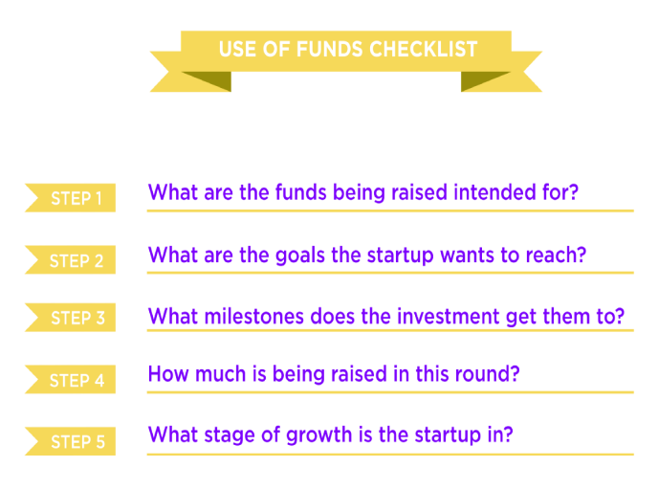

**Types and Sources of Financing for Start-up Businesses**

Financing is needed to start a business and ramp it up to proﬁtability. There are several sources to consider when looking for start-up ﬁnancing. But ﬁrst you need to consider how much money you need and when you will need it.

The ﬁnancial needs of a business will vary according to the type and size of the business. For example, processing businesses are usually capital intensive, requiring large amounts of capital. Retail businesses usually require less capital.

Debt and equity are the two major sources of ﬁnancing. Government grants to ﬁnance certain aspects of a business may be an option. Also, incentives may be available to locate in certain communities and/or encourage activities in particular industries.

**Equity Financing**

Equity ﬁnancing means exchanging a portion of the ownership of the business for a financial investment in the business. The ownership stake resulting from an equity investment allows the investor to share in the company’s proﬁts. Equity involves a permanent investment in a company and is not repaid by the company at a later date.

The investment should be properly deﬁned in a formally created business entity. An equity stake in a company can be in the form of membership units, as in the case of a limited liability company or in the form of common or preferred stock as in a corporation.   
Companies may establish different classes of stock to control voting rights among shareholders. Simi­larly, companies may use different types of preferred stock. For example, common stockholders can vote while preferred stockholders generally cannot. But common stockholders are last in line for the company’s assets in case of default or bankruptcy. Preferred stockholders receive a predetermined dividend before common stockholders receive a dividend.

*Personal Savings*  
The ﬁrst place to look for money is your own savings or equity. Personal resources can include proﬁt-sharing or early retirement funds, real estate equity loans, or cash value insurance policies.

Life insurance policies - A standard feature of many life insurance policies is the owner’s ability to borrow against the cash value of the policy. This does not include term insurance because it has no cash value. The money can be used for business needs. It takes about two years for a policy to accumulate sufﬁcient cash value for borrowing. You may borrow most of the cash value of the policy. The loan will reduce the face value of the policy and, in the case of death, the loan has to be repaid before the beneﬁciaries of the policy receive any payment.

Home equity loans - A home equity loan is a loan backed by the value of the equity in your home. If your home is paid for, it can be used to generate funds from the entire value of your home. If your home has an existing mortgage, it can provide funds on the difference between the value of the house and the unpaid mortgage amount. For example, if your house is worth $150,000 with an outstanding mortgage of $60,000, you have $90,000 in equity you can use as collateral for a home equity loan or line of credit. Some home equity loans are set up as a revolving credit line from which you can draw the amount needed at any time. The interest on a home equity loan is tax deductible.

*Friends and Relatives*  
Founders of a start-up business may look to private ﬁnancing sources such as parents or friends. It may be in the form of equity ﬁnancing in which the friend or relative receives an ownership interest in the business. However, these investments should be made with the same formality that would be used with outside investors.

*Venture Capital*  
Venture capital refers to ﬁnancing that comes from companies or individuals in the business of investing in young, privately held businesses. They provide capital to young businesses in exchange for an ownership share of the business. Venture capital ﬁrms usually don’t want to participate in the initial ﬁnancing of a business unless the company has management with a proven track record. Generally, they prefer to invest in companies that have received signiﬁcant equity investments from the founders and are already proﬁtable.

They also prefer businesses that have a competitive advantage or a strong value proposition in the form of a patent, a proven demand for the product, or a very special (and protectable) idea. Venture capital investors often take a hands-on approach to their investments, requiring representation on the board of directors and sometimes the hiring of managers. Venture capital investors can provide valuable guid­ance and business advice. However, they are looking for substantial returns on their investments and their objectives may be at cross purposes with those of the founders. They are often focused on short-term gain.

Venture capital ﬁrms are usually focused on creating an investment portfolio of businesses with high-growth potential resulting in high rates of returns. These businesses are often high-risk investments. They may look for annual returns of 25 to 30 percent on their overall investment portfolio.

Because these are usually high-risk business investments, they want investments with expected returns of 50 percent or more. Assuming that some business investments will return 50 percent or more while others will fail, it is hoped that the overall portfolio will return 25 to 30 percent.

More speciﬁcally, many venture capitalists subscribe to the 2-6-2 rule of thumb. This means that typically two investments will yield high returns, six will yield moderate returns (or just return their original investment), and two will fail.

*Angel Investors*  
Angel investors are individuals and businesses that are interested in helping small businesses survive and grow. So their objective may be more than just focusing on economic returns. Although angel inves­tors often have somewhat of a mission focus, they are still interested in proﬁtability and security for their investment. So they may still make many of the same demands as a venture capitalist.

Angel investors may be interested in the economic development of a speciﬁc geographic area in which they are located. Angel investors may focus on earlier stage ﬁnancing and smaller financing amounts than venture capitalists.

*Government Grants*  
Federal and state governments often have ﬁnancial assistance in the form of grants and/or tax credits for start-up or expanding businesses.

*Equity Offerings*  
In this situation, the business sells stock directly to the public. Depending on the circumstances, equity offerings can raise substantial amounts of funds. The structure of the offering can take many forms and requires careful oversight by the company’s legal representative.

*Initial Public Offerings*  
Initial Public Offerings (IPOs) are used when companies have proﬁtable operations, management stability, and strong demand for their products or services. This generally doesn’t happen until compa­nies have been in business for several years. To get to this point, they usually will raise funds privately one or more times.

*Warrants*  
Warrants are a special type of instrument used for long-term ﬁnancing. They are useful for start-up companies to encourage investment by minimizing downside risk while providing upside potential. For example, warrants can be issued to management in a start-up company as part of the reimbursement package.

A warrant is a security that grants the owner of the warrant the right to buy stock in the issuing com­pany at a pre-determined (exercise) price at a future date (before a speciﬁed expiration date). Its value is the relationship of the market price of the stock to the purchase price (warrant price) of the stock. If the market price of the stock rises above the warrant price, the holder can exercise the warrant. This involves purchasing the stock at the warrant price. So, in this situation, the warrant provides the oppor­tunity to purchase the stock at a price below current market price.

If the current market price of the stock is below the warrant price, the warrant is worthless because exercising the warrant would be the same as buying the stock at a price higher than the current market price. So, the warrant is left to expire. Generally warrants contain a speciﬁc date at which they expire if not exercised by that date.

**Debt Financing**

Debt ﬁnancing involves borrowing funds from creditors with the stipulation of repaying the borrowed funds plus interest at a speciﬁed future time. For the creditors (those lending the funds to the business), the reward for providing the debt ﬁnancing is the interest on the amount lent to the borrower.

Debt ﬁnancing may be secured or unsecured. Secured debt has collateral (a valuable asset which the lender can attach to satisfy the loan in case of default by the borrower). Conversely, unsecured debt does not have collateral and places the lender in a less secure position relative to repayment in case of default.

Debt ﬁnancing (loans) may be short term or long term in their repayment schedules. Generally, short-term debt is used to ﬁnance current activities such as operations while long-term debt is used to ﬁnance assets such as buildings and equipment.

*Friends and Relatives*  
Founders of start-up businesses may look to private sources such as family and friends when starting a business. This may be in the form of debt capital at a low interest rate. However, if you borrow from relatives or friends, it should be done with the same formality as if it were borrowed from a commercial lender. This means creating and executing a formal loan document that includes the amount borrowed, the interest rate, speciﬁc repayment terms (based on the projected cash ﬂow of the start-up business), and collateral in case of default.

*Banks and Other Commercial Lenders*  
Banks and other commercial lenders are popular sources of business ﬁnancing. Most lenders require a solid business plan, positive track record, and plenty of collateral. These are usually hard to come by for a start- up business. Once the business is underway and proﬁt and loss statements, cash ﬂows budgets, and net worth statements are provided, the company may be able to borrow additional funds.

*Commercial Finance Companies*  
Commercial ﬁnance companies may be considered when the business is unable to secure financing from other commercial sources. These companies may be more willing to rely on the quality of the collateral to repay the loan than the track record or profit projections of your business. If the business does not have substantial personal assets or collateral, a commercial ﬁnance company may not be the best place to secure ﬁnancing. Also, the cost of finance company money is usually higher than other commercial lenders.

*Government Programs*  
Federal, state, and local governments have programs designed to assist the ﬁnancing of new ventures and small businesses. The assistance is often in the form of a government guarantee of the repayment of a loan from a conventional lender. The guarantee provides the lender repayment assurance for a loan to a business that may have limited assets available for collateral. The best known sources are the Small Business Administration and the USDA Rural Development programs.

*Bonds*  
Bonds may be used to raise ﬁnancing for a speciﬁc activity. They are a special type of debt ﬁnancing because the debt instrument is issued by the company. Bonds are different from other debt ﬁnancing instruments because the company speciﬁes the inter­est rate and when the company will pay back the principal (maturity date). Also, the company does not have to make any payments on the principal (and may not make any interest payments) until the specified maturity date. The price paid for the bond at the time it is issued is called its face value.

When a company issues a bond it guarantees to pay back the principal (face value) plus interest. From a ﬁnancing perspective, issuing a bond offers the company the opportunity to access financing without having to pay it back until it has successfully applied the funds. The risk for the investor is that the com­pany will default or go bankrupt before the maturity date. However, because bonds are a debt instrument, they are ahead of equity holders for company assets.

**Lease**

A lease is a method of obtaining the use of assets for the business without using debt or equity ﬁnanc­ing. It is a legal agreement between two parties that speciﬁes the terms and conditions for the rental use of a tangible resource such as a building and equipment. Lease payments are often due annually. The agreement is usually between the company and a leasing or ﬁnancing organization and not directly between the company and the organization providing the assets. When the lease ends, the asset is returned to the owner, the lease is renewed, or the asset is purchased.

A lease may have an advantage because it does not tie up funds from purchasing an asset. It is often compared to purchasing an asset with debt ﬁnancing where the debt repayment is spread over a period of years. However, lease payments often come at the beginning of the year where debt payments come at the end of the year. So, the business may have more time to generate funds for debt payments, although a down payment is usually required at the beginning of the loan period.

**Fixed and working capital**

Every organization requires money to carry on the business activities and the money required by the organization is termed as CAPITAL. The capital is mainly divided into two types

1. Fixed Capital  
2. Working Capital.

The modern finance manager has to take decisions to efficiently allocate the**fixed capital and working capital**among the investments of fixed assets and current assets to ensure the smooth running  
of the organization in the long run.

The words of H. G. Guthmann clearly explain the importance of working capital. “Working Capital is the lifeblood and nerve center of the business.”

In the words of Walker, “A firm’s profitability is determined in part by the way its working capital is managed.”

## ****FIXED CAPITAL****

Fixed capital refers to the funds invested in fixed or permanent assets as land, building, and machinery etc by the organization.Fixed capital is required for establishment of business. Fixed capital invested in the long term assets is very important since it determines the value of firm through the growth, profitability, and risk. Fixed capital also refers to investment in intangible assets like copyrights, patents, goodwill, organization.

## ****WORKING CAPITAL****

working capital refers to the funds which are invested in materials, work in progress, finished goods, receivables, and cash etc. Working capital is required to utilize fixed assets of the company. Working capital plays a key role in a business enterprise. The efficiency of the business enterprise largely depends on its ability to manage its working capital. Working Capital is concerned with the management of firm’s current assets and current liabilities.

### COMPARISON TABLE

There exist numerous differences between Fixed Capital and Working Capital, some of them are as follows.

| **FIXED CAPITAL** | | **WORKING CAPITAL** |
| --- | --- | --- |
| Fixed capital may be defined as capital invested in long-term assets. | | Working capital may be defined as capital invested in current assets |
| **Requirement** | | |
| Fixed capital is required for establishment of business. | Working capital is required to utilize fixed assets of the company. | |
| **Sources of Funds** | | |
| The industrial units mobilize fixed capital from various sources like shares, debentures, banks etc. which are to be repaid over long time period. | The industrial units mobilize working capital from the commercial bank loans, profits retained, etc. which are repayable before one year. | |
| **Conversion** | | |
| The fixed capital which is used for fixed assets is not easily convertible into cash. | The working capital investments have high liquidity and can be easily convertible into cash. | |
| **Nature** | | |
| Fixed capital is a one-time investment to purchase fixed assets for starting a business or for expanding a business. | Working capital is required constantly for day to day business activities of the organization. | |
| **Duration** | | |
| Fixed capital in long-term investment i.e it is invested at the for long periods of time. | Working capital is usually a short term investment for running of businesses day to day operations. | |
| **Returns** | | |
| Fixed capital aims at long-term return to the organization. | Working capital is generally focused on meeting the daily requirements for operational activities of the organization. | |
| **Amount Required** | | |
| Fixed capital constitute a very large amount of investments done by the organization. | Working capital required is considerably less in amount when compared to Fixed Capital of the organization. | |
| **Assets** | | |
| Fixed capital invested in long-term fixed assets is studied under "Capital Budgeting". | Working capital invested in current assets is studied under "Working Capital Management". | |

Material Resources: Supply and distribution chains

Globalization has become an undeniable part of commerce over the last few decades, as large companies have grown first to source labor and parts from developing regions, and then to start selling in those same areas as they grew in wealth and buying power. Supply chains have had to keep in step, passing through numerous countries to obtain goods most efficiently and cost effectively, and growing more complex as a result.

**WHAT IS A SUPPLY CHAIN?**

A supply chain is a collection of suppliers required to create one specific product for a company. The chain is made up of nodes or “links,” which can include multiple manufacturers for parts, then the completed product, then the warehouse where it is stored, then its distribution centers, and finally, the store where a consumer can purchase it. The concept of the chain is important, because each link is connected in a specific direction and order, and the next link cannot be reached without going through the previous one. Each link adds time and costs, and can involve labor, parts, and transportation. Every product a company carries may have its own supply chain, though they may use certain suppliers for multiple products. You can see why this gets so complicated, especially for international supply chains.

The process described above was that of a typical retail supply chain. However, there are many different types in practice. Here are three examples from well-known masters of supply chains:   
   
**Example: Walmart and “Big Box” Retailers**  
The “Big Box” store, which represents one of the major disruptions of the retail model from the last century, thrives on size, ubiquity, and well-planned supply chains to drive out the competition. How else would a company like Walmart make a profit on a t-shirt made overseas that retails for $5.00?  
   
Walmart succeeds by having fewer links in its supply chain, and buying more generic goods directly from manufacturers, rather than from suppliers with brand names and markup. It uses “Vendor Managed Inventory” to mandate that manufacturers are responsible for managing products in warehouses owned by Walmart. The company is also is particularly choosy with suppliers, partnering only with those who can meet the quantity and frequency it demands with low prices, and with locations that limit transportation needs. They manage their supply chain like one firm, with all partners operating on the same communication network.   
   
By buying at large enough quantities to take advantage of economies of scale, moving products directly from manufacturers to warehouses, and then delivering to stores which are large enough to be distribution centers, it reduces links in the supply chain and cost per item, translating to low prices for consumers.

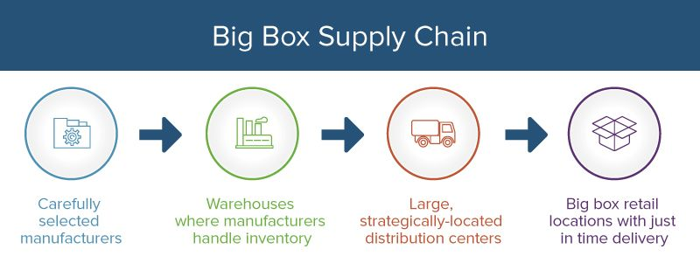

**Example: Amazon and “Ecommerce Platforms”**  
Having overtaken Walmart as the world’s largest retailer in the last decade, Amazon’s “online big box” concept is a perfect example of unique supply chains. As an e-commerce shop, obviously they cut the retail store out and ship from distribution center to consumer’s homes directly. Where Amazon innovates is both in its supplier-side and its final supply chain link - delivery.   
   
Just about anyone can sell things on Amazon because it’s a platform, not just a shop. As a result, Amazon has more things than any other online store, so when people shop online, they think of Amazon. Then, it produces everyday goods cheaply, and underbids suppliers. Next, their warehouses make serious use of automation to store items going to like destinations together, ready for immediate transport. Finally, its investments in delivery staff and technology make 2-day shipping a basic expectation, and even same-day delivery a possibility. Amazon ditches third-party logistics (3PL) and fulfills orders itself.

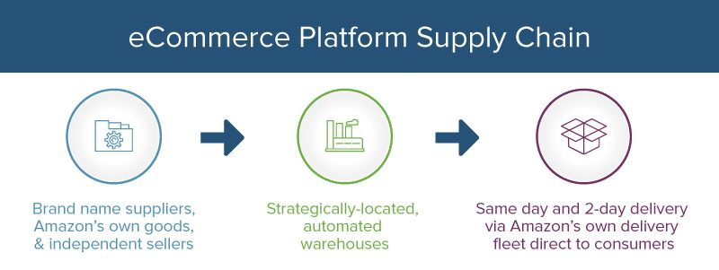

**Example: Tesla and Specialized, Owned Chains**  
Automotive manufacturing has come a long way since Henry Ford used assembly line manufacturing to speed up the production of a single car model in a single color. Now, in a time when even American carmakers are opening factories abroad, Tesla is making innovative, incredibly popular, and luxurious cars right in California, a location with incredibly costly real estate.  
   
Rather than having a long supply chain of cheap part makers, they have a vertically integrated supply chain, with a full-service auto plant near its corporate headquarters and plans for a supplier park and a massive battery factory, and Tesla owns it all. Even more interesting is the digital supply chain the company promotes - new firmware and algorithm updates are pushed out to existing car owners over the cloud.

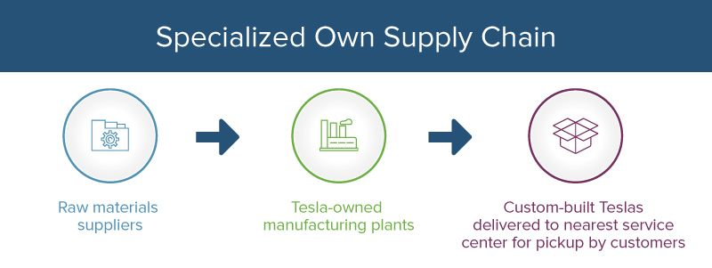

**WHAT IS SUPPLY CHAIN MANAGEMENT?**

As the name implies, supply chain management (SCM) is handling and optimizing all the many complicated facets of a supply chain, involving goods and services. Even ensuring timely handoff from manufacturer to shipper to supplier to shipper to buyer is a massive task, but to do it cost effectively and build net value is truly a challenge.   
   
Supply chain management is so important because modern commerce exists in a networked global economy. Most businesses are specialized - even department and big box stores are only really equipped to sell to customers, despite their wide variety of products. The value of vertical integration is hard to justify when communication costs and SCM tools are so inexpensive - it almost always makes more sense to outsource for price efficiency.

**HISTORY**

The concept of supply chain management was in effect long before the term was created in 1982. In the colonial era, international trade by ship was already making for complicated transportation issues and the need for efficiency. During the Industrial Revolution, the ability to quickly produce goods with machine assistance led to the need to manage significant inventory and constant consumption. By the time history arrives at Henry Ford’s famous assembly line for the world’s first car production in 1913, supply chain management had become an art.   
   
As the century wore on, more companies were producing more goods and looking for ways to reduce costs. They vertically integrated into owned supply chains to try reducing costs at each stage. In the 1980s and on, globalization became a realistic dream for many companies, because of computer systems, easier communication, and commerce-friendly trade laws. Around the 1990s, it became a common practice for firms to specialize, and focus on core competencies and outsourcing the rest, abandoning the vertical integration of the previous era. At this point, supply chains became truly complex, in order to coordinate hundreds of otherwise unrelated and geographically-distant manufacturers, suppliers, shippers, warehousers, and retailers.   
   
Now, in the “SCM 2.0” era, the Internet and new methodologies have led to collaborative platforms and democratized processes. This is allowing smaller competitors to use some of the same manufacturers as major players, and reducing inefficiencies for those manufacturers as a  result. Better communication and planning tools are providing a way for small and large companies alike to manage even more complex supply chains.

**VARIANTS OF SCM**

**Global SCM:** The combination of global manufacturing with supply chain management, which must account for tariffs and local taxes as goods and services travel internationally to ultimately provide greater value at the end of the chain.  
   
**SAP SCM:** Systems, Applications, and Products (SAP) is a software company that revolutionized logistics and enterprise resource planning. It provides an automated way to manage supply chain networking, supply chain planning, and supply chain execution, along with production planning, business forecasting, and demand planning.  
   
**Logistics and SCM:** The art of coordinating efforts between every member of the supply chain to get products from their source to the consumer.   
   
**Purchasing and SCM:** The focus on the monetary aspect of SCM, from costs to value added at each link in the supply chain.

**PRINCIPLES OF GOOD SUPPLY CHAIN STRATEGY**

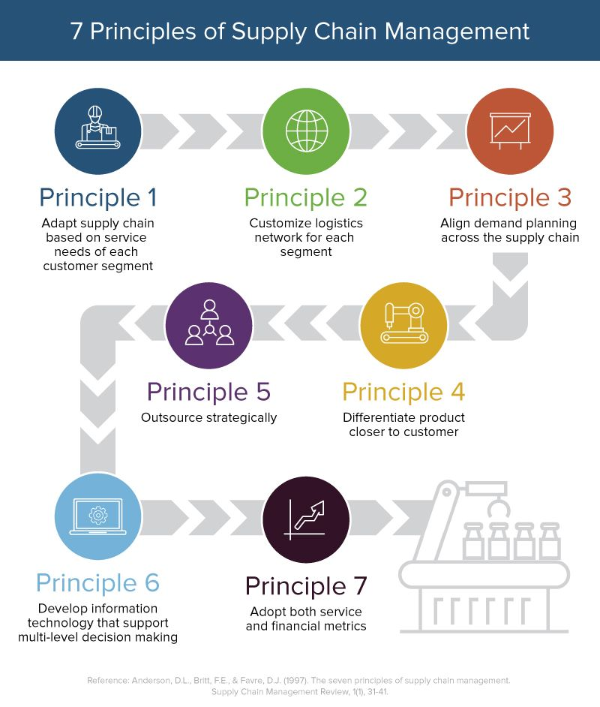

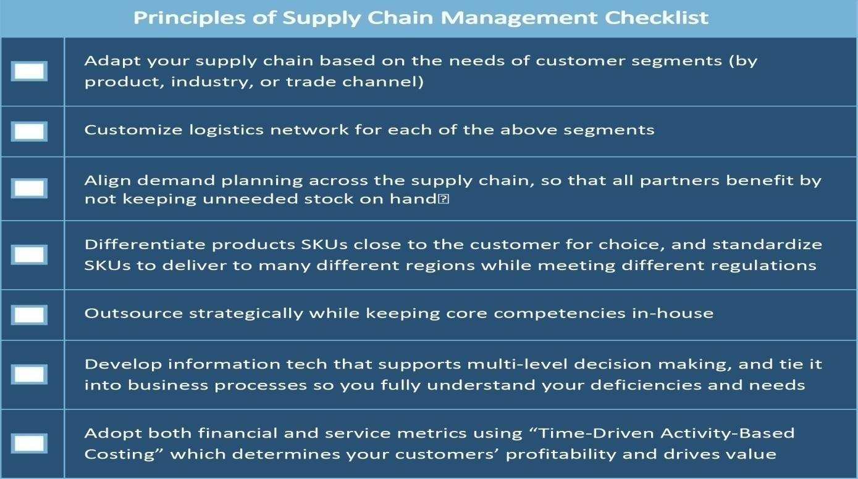

**THE BASICS OF SUPPLY CHAIN MANAGEMENT PROCESSES**

There are key supply chain processes that you must take into consideration to effectively understand and manage them. These processes are all at play regardless of the type of supply chain you’re using.  
   
**Customer relationship management (CRM)** comes first, because as the principles of SCM state, you must adapt everything in the supply chain to the customer. If no one is buying, there’s no need to produce anything. At the front of your supply chain, where a store’s staff interacts with its consumers, they must have plans in place for ongoing relationships. They need CRM tools to gather customer information for marketing and market research, all to determine the products and services to offer in the future.  
   
**Customer service management** is another process that ties in, as it is where you gather negative and positive feedback to determine future needs.  
   
**Demand management** is closely linked with the previous two, as it takes customer interactions and orders into account to determine the workload all the way up the supply chain. At its core, customers buying more means make more, and customers buying less means make less. Customer forecasting is an important task that analysts must perform well to determine the current demand and what it will be in the future, to prevent waste in the supply chain.  
   
**Product development**is an important part of the supply chain that is informed by consumer demand. You must work with CRM and customer service data to determine what they want, which influences new products, product line extensions, and also what to stop making. You must integrate suppliers in this process because it affects cost, quality, and delivery time.  
   
**Supplier relationship management** goes without saying - if you want to produce your products on time and on budget, you need a solid rapport with everyone you’re outsourcing to in the chain. This impacts **manufacturing flow management**, which ensures everything gets where it needs to go without delay, and at the correct spec.   
   
**Order fulfilment** involves coordinating with distribution centers and either retail locations or 3PL to get the product direct to consumers. You’ve now made it all the way back to the beginning of the cycle, and need to pay attention to new CRM and customer service data.  
   
**Returns management**, also known as the “reverse supply chain,” is a vital part of the flow of products that doesn’t fit perfectly into the clean supply chain cycle. It involves picking up online orders from 3PL locations or from consumers’ addresses and accepting returns at retail locations. Once these items are put back into inventory, they must be ready to get to a different customer while the product run is still live.

**WHAT SUPPLY CHAIN MANAGERS LOOK FOR WHEN MANAGING SUPPLIER RELATIONSHIPS**

One of the most complex parts of SCM is handling all the other people in the supply chain. They have their own needs and motivations, and to keep them all happy and working together with partners they are only loosely affiliated with is a challenge - especially when trying to meet deadlines and turn a profit. The following are what managers should focus on most in such relationships:  
   
**Org Chart and Leadership Style:** How is the supplier’s organization set up? Is it a vertical or horizontal structure? Is the leadership strong and long lasting, or fickle and prone to change? You need to know who you’ll be interfacing with, and who will be the next one in line should some shakeup occur. Business relationships are always between people, and don’t always survive a reorg.   
   
**Management Style:** How do the leaders at this supplier run their shop? Make sure it works with your crew. A micromanager at a relatively replaceable link in your supply chain will waste inordinate time, just as a hands-off manager at a vital link could result in sloppy delivery or substandard product quality.  
   
**Company Culture:**Always important for working with suppliers, determine what kinds of people rise to the top, and how everyone acts when nobody's watching. If, for example, middle managers are constantly in fear for their jobs because of ruthless quarterly performance reviews, they may over-promise, make excuses, or otherwise be unstable work partners.   
   
**Product Flows:** Once you know that you can work with the people, make sure their facilities are in order. Are they equipped for orders of the size and frequency you plan to make? How do they handle emergency, fast-turn around orders? What about other customers - are they only able to use their facilities for your product flows at certain portions of the month due to full inventory? Leave no stone unturned.  
   
**Information Flows:** Just as vital is the ability to control information about the day-to-day flow of materials, and to communicate and coordinate long-term plans. Is the supplier up on their product details, inventory, and SKU organization? Is their security and encryption up to the standards of your company, and your industry? Big data is useless if the right people don’t see it in time.  
   
**Rewards and Risks:** Take into account opportunities and threats of working with this supplier. Maybe they’re well-equipped to handle your exact product because they also work with your competitors. Perhaps they are new and establishing themselves, so offer a substantial discount, but may not be able to deliver on time? Do what’s best for the company, and use [risk assessment](https://www.smartsheet.com/all-risk-assessment-matrix-templates-you-need) to keep your whole supply chain operable.

**Distribution Channel**

Distribution channel refers to the network used to get a product from the manufacturer or creator to the end user.

When a distribution channel is “direct,” the manufacturer is selling directly to the end user without a middleman. When the distribution channel is “indirect,” the product changes hands several times before reaching the ultimate consumer. Intermediaries between the manufacturer and the consumer in an indirect distribution channel might include:

* Wholesaler/distributor
* Dealer
* Retailer
* Consultant
* Manufacturer’s representative
* Catalog

There might be just one intermediary; there might be many.

Direct vs. Indirect Distribution Channels

A company that sells directly to consumers through direct mail, a catalog of its own products, or its own ecommerce site represents a business that uses a direct distribution channel. For example, entrepreneurs who create and sell digital products that include workbooks, audio training, and online courses from their own websites are using a direct distribution channel. The digital products go directly from the creator to the customer.

On a larger scale, the beverage alcohol industry uses a multi-tier, indirect distribution channel. Distillers and wineries sell to distributors, who sell to retailers, who sell to consumers. But while wineries must use indirect distribution channels to get their wines into retail outlets where consumers can buy them, many also sell directly to consumers onsite at wineries. Using both approaches lets wineries reach a mass market through an indirect distribution channel and a smaller market through direct distribution via on-site retail operations that they own.

A distribution channel can have several stages depending on how many organisations are involved in it:

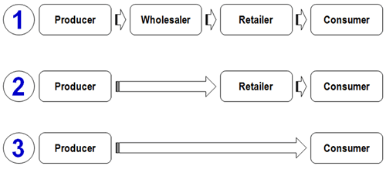

*Looking at the diagram above:*

Channel 1 contains two stages between producer and consumer - a **wholesaler**and a **retailer.** A wholesaler typically buys and stores large quantities of several producers' goods and then **breaks into bulk**deliveries to supply retailers with smaller quantities. For small retailers with limited order quantities, the use of wholesalers makes economic sense.

Channel 2 contains one intermediary. In consumer markets, this is typically a **retailer**. The consumer electrical goods market in the UK is typical of this arrangement whereby producers such as Sony, Panasonic, Canon etc. sell their goods directly to large retailers such as Comet, Tesco and Amazon which then sell onto the final consumers.

Channel 3 is called a "**direct-marketing" channel**, since it has no intermediary levels. In this case the manufacturer sells directly to customers. An example of a direct marketing channel would be a factory outlet store. Many holiday companies also market direct to consumers, bypassing a traditional retail intermediary - the travel agent.

Distribution Channel Considerations

Businesses with products should ask a number of questions before determining a distribution program. Those questions include:

* How does the end-user like to purchase these types of products? Does the consumer want to touch and examine the product or is it a product that the target audience likes to buy online?
* What, if any, are the local, regional, or national regulations regarding the product category’s distribution channels?
* Does the customer need personalized service?
* Does the product itself need to be serviced?
* Does the product need to be installed?
* How is the product typically distributed and sold in your industry?

The distribution channel will have an impact on pricing. With indirect distribution, a product that goes from the manufacturer to a distributor before it goes to a retail outlet needs to be priced at wholesale so that both the distributor and retailer can mark up the price. With a multi-tier distribution channel, it looks like this:

* The manufacturer’s customer is the distributor.
* The distributor’s customer is the retailer.
* The retailer’s customer is the consumer.

The manufacturer, distributor, and retailer all need to make money on that product.

The direct-to-consumer price is often the same as the price of a product that has been marked up several times through indirect distribution. Not offering a “direct to you” discount protects retailer relationships and offers the manufacturer or creator a higher profit on the product.

**Government and local resources**

**Government of India Support for Innovation and Entrepreneurship in India**

The Government of India has undertaken several initiatives and instituted policy measures to foster a culture of innovation and entrepreneurship in the country. Job creation is a foremost challenge facing India. With a significant and unique demographic advantage, India, however, has immense potential to innovate, raise entrepreneurs and create jobs for the benefit of the nation and the world.

In the recent years, a wide spectrum of new programmes and opportunities to nurture innovation have been created by the Government of India across a number of sectors. From engaging with academia, industry, investors, small and big entrepreneurs, non-governmental organizations to the most underserved sections of society.

Recognising the importance of women entrepreneurship and economic participation in enabling the country’s growth and prosperity, Government of India has ensured that all policy initiatives are geared towards enabling equal opportunity for women. The government seeks to bring women to the forefront of India’s entrepreneurial ecosystem by providing access to loans, networks, markets and trainings.

A few of India’s efforts at promoting entrepreneurship and innovation are:

·         **[Startup India](https://youtu.be/orzNC8lClKk)**: Through the Startup India initiative, Government of India promotes entrepreneurship by mentoring, nurturing and facilitating startups throughout their life cycle. Since its launch in January 2016, the initiative has successfully given a head start to numerous aspiring entrepreneurs. With a 360 degree approach to enable startups, the initiative provides a comprehensive four-week free online learning program, has set up research parks, incubators and startup centres across the country by creating a strong network of academia and industry bodies. More importantly, a ‘Fund of Funds’ has been created to help startups gain access to funding. At the core of the initiative is the effort to build an ecosystem in which startups can innovate and excel without any barriers, through such mechanisms as online recognition of startups, Startup India Learning Programme, Facilitated Patent filing, Easy Compliance Norms, Relaxed Procurement Norms, incubator support, innovation focused programmes for students, funding support, tax benefits and addressing of regulatory issues.

·         [**Make in India**](http://www.makeinindia.com/about): Designed to transform India into a global design and manufacturing hub, the Make in India initiative was launched in September 2014. It came as a powerful call to India’s citizens and business leaders, and an invitation to potential partners and investors around the world to overhaul out-dated processes and policies, and centralize information about opportunities in India’s manufacturing sector. This has led to renewed confidence in India’s capabilities among potential partners abroad, business community within the country and citizens at large. The plan behind Make in India was one of the largest undertaken in recent history. Among several other measures, the initiative has ensured the replacement of obsolete and obstructive frameworks with transparent and user-friendly systems. This has in turn helped procure investments, foster innovation, develop skills, protect intellectual property and build best-in-class manufacturing infrastructure.  
  
·         **[Atal Innovation Mission (AIM](http://aim.gov.in/index.php)**[)](http://aim.gov.in/index.php): AIM is the Government of India’s endeavour to promote a culture of innovation and entrepreneurship, and it serves as a platform for promotion of world-class Innovation Hubs, Grand Challenges, start-up businesses and other self-employment activities, particularly in technology driven areas. In order to foster curiosity, creativity and imagination right at the school, AIM recently launched Atal Tinkering Labs (ATL) across India. ATLs are workspaces where students can work with tools and equipment to gain hands-on training in the concepts of STEM (Science, Technology, Engineering and Math). Atal Incubation Centres (AICs) are another programme of AIM created to build innovative start-up businesses as scalable and sustainable enterprises. AICs provide world class incubation facilities with appropriate physical infrastructure in terms of capital equipment and operating facilities. These incubation centres, with a presence across India, provide access to sectoral experts, business planning support, seed capital, industry partners and trainings to encourage innovative start-ups.

·         [**Support to Training and Employment Programme for Women (STEP**)](http://wcd.nic.in/schemes/support-training-and-employment-programme-women-step): STEP was launched by the Government of India’s Ministry of Women and Child Development to train women with no access to formal skill training facilities, especially in rural India. The Ministry of Skill Development & Entrepreneurship and NITI Aayog recently redrafted the Guidelines of the 30-year-old initiative to adapt to present-day needs. The initiative reaches out to all Indian women above 16 years of age. The programme imparts skills in several sectors such as agriculture, horticulture, food processing, handlooms, traditional crafts like embroidery, travel and tourism, hospitality, computer and IT services.

·         [**Jan Dhan- Aadhaar- Mobile (JAM)**](http://pib.nic.in/newsite/PrintRelease.aspx?relid=136865): JAM, for the first time, is a technological intervention that enables direct transfer of subsidies to intended beneficiaries and, therefore, eliminates all intermediaries and leakages in the system, which has a protential impact on the lives of millions of Indian citizens. Besides serving as a vital check on corruption, JAM provides for accounts to all underserved regions, in order to make banking services accessible down to the last mile.

·         [**Digital India**](http://www.digitalindia.gov.in/content/introduction)**:**The Digital India initiative was launched to modernize the Indian economy to makes all government services available electronically. The initiative aims to transform India into a digitally-empowered society and knowledge economy with universal access to goods and services. Given historically poor internet penetration, this initiative aims to make available high-speed internet down to the grassroots. This program aims to improve citizen participation in the digital and financial space, make India’s cyberspace safer and more secure,abd improve ease of doing business. Digital India hopes to achieve equity and efficiency in a country with immense diversity by making digital resources and services available in all Indian languages.

·         [**Biotechnology Industry Research Assistance Council (BIRAC)**](http://www.birac.nic.in/desc_new.php?id=89)**:**BIRAC is a not-for-profit Public-Sector Enterprise, set up by Department of Biotechnology to strengthen and empower emerging biotechnology enterprises. It aims to embed strategic research and innovation in all biotech enterprises, and bridge the existing gaps between industry and academia. The ultimate goal is to develop high-quality, yet affordable, products with the use of cutting edge technologies. BIRAC has initiated partnerships with several national and global partners for building capacities of the Indian biotech industry, particularly start-ups and SME’s, and has facilitated several rapid developments in medical technology.

·         [**Department of Science and Technology (DST)**](http://www.dst.gov.in/about-us/introduction)**: T**he DST comprises several arms that work across the spectrum on all major projects that require scientific and technological intervention. The Technology Interventions for Disabled and Elderly, for instance, provides technological solutions to address challenges and improve quality of life of the elderly in India through the application of science and technology. On the other hand, the *ASEAN-India Science, Technology and Innovation* Cooperation works to narrow the development gap and enhance connectivity between the ASEAN countries. It encourages cooperation in science, technology and innovation through joint research across sectors and provides fellowships to scientists and researchers from ASEAN member states with Indian R&D/ academic institutions to upgrade their research skills and expertise.

·         [**Stand-Up India**](https://www.standupmitra.in/Home/AboutUs)**:**Launched in 2015, Stand-Up India seeks to leverage institutional credit for the benefit of India’s underprivileged. It aims to enable economic participation of, and share the benefits of India’s growth, among women entrepreneurs, Scheduled Castes and Scheduled Tribes. Towards this end, at least one women and one individual from the SC or ST communities are granted loans between Rs.1 million to Rs.10 million to set up greenfield enterprises in manufacturing, services or the trading sector. The Stand-Up India portal also acts as a digital platform for small entrepreneurs and provides information on financing and credit guarantee.

·         [**Trade related Entrepreneurship Assistance and Development (TREAD)**](http://www.dcmsme.gov.in/schemes/treadwomen.htm)**:**To address the critical issues of access to credit among India’s underprivileged women, the TREAD programme enables credit availability to interested women through non-governmental organizations (NGOs). As such, women can receive support of registered NGOs in both accessing loan facilities, and receiving counselling and training opportunities to kick-start proposed enterprises, in order to provide pathways for women to take up non-farm activities.

·         **[Pradhan Mantri Kaushal Vikas Yojana (PMKVY):](http://www.pmkvyofficial.org/Index.aspx)**A flagship initiative of the Ministry of Skill Development & Entrepreneurship (MSDE), this is a Skill Certification initiative that aims to train youth in industry-relevant skills to enhance opportunities for livelihood creation and employability. Individuals with prior learning experience or skills are also assessed and certified as a Recognition of Prior Learning. Training and Assessment fees are entirely borne by the Government under this program.

·         [**National Skill Development Mission**](http://www.skilldevelopment.gov.in/nationalskillmission.html)**:**Launched in July 2015, the mission aims to build synergies across sectors and States in skilled industries and initiatives. With a vision to build a ‘Skilled India’ it is designed to expedite decision-making across sectors to provide skills at scale, without compromising on quality or speed. The seven sub-missions proposed in the initial phase to guide the mission’s skilling efforts across India are: (i) Institutional Training (ii) Infrastructure (iii) Convergence (iv) Trainers (v) Overseas Employment (vi) Sustainable Livelihoods (vii) Leveraging Public Infrastructure.

·       [**Science for Equity Empowerment and Development (SEED)**](http://dst.gov.in/scientific-programmes/st-and-socio-economic-development/science-equity-empowerment-and-development-seed)**:**SEED aims to provide opportunities to motivated scientists and field level workers to undertake action-oriented, location specific projects for socio-economic gain, particularly in rural areas. Efforts have been made to associate national labs and other specialist S&T institutions with innovations at the grassroots to enable access to inputs from experts, quality infrastructure. SEED emphasizes equity in development, so that the benefits of technological accrue to a vast section of the population, particularly the disadvantaged.

**Human Resources**

Human resources is used to describe both the people who work for a company or organization and the department responsible for managing resources related to employees. The term *human resources* was first coined in the 1960s when the value of labor relations began to garner attention and when notions such as motivation, organizational behavior, and selection assessments began to take shape.

Human resource management is a contemporary, umbrella term used to describe the management and development of employees in an organization. Also called personnel or talent management (although these terms are a bit antiquated), human resource management involves overseeing all things related to managing an organization’s human capital.

Human resource management is therefore focused on a number of major areas, including:

* Recruiting and staffing
* Compensation and benefits
* Training and learning
* Labor and employee relations
* Organization development

Due to the many areas of human resource management, it is typical for professionals in this field to possess specific expertise in one or more areas. Just a few of the related career titles for HR professionals include:

* Training development specialist
* HR manager
* Benefits specialist
* Human resource generalist
* Employment services manager
* Compensation and job analysis specialist
* Training and development manager
* Recruiter
* Benefits counselor
* Personnel analyst

Human resource management involves developing and administering programs that are designed to increase the effectiveness of an organization or business. It includes the entire spectrum of creating, managing, and cultivating the employer-employee relationship.

For most organizations, agencies, and businesses, the human resources department is responsible for:

* Managing job recruitment, selection, and promotion
* Developing and overseeing employee benefits and wellness programs
* Developing, promoting, and enforcing personnel policies
* Promoting employee career development and job training
* Providing orientation programs for new hires
* Providing guidance regarding disciplinary actions
* Serving as a primary contact for work-site injuries or accidents

Human resource management is about:

***Addressing current employee concerns*:** Unlike company managers who oversee the day-to-day work of employees, HR departments deal with employee concerns such as benefits, pay, employee investments, pension plans, and training. Their work may also include settling conflicts between employees or between employees and their managers.

***Acquiring new employees*:** The human resource management team recruits potential employees, oversees the hiring process (background checks, drug testing, etc.), and provides new employee orientation.

***Managing the employee separation process*:** The HR management team must complete a specific set of tasks if an employee quits, is fired, or is laid off. Paperwork must be completed to ensure that the process was completed legally. Severance pay may be offered or negotiated, benefits must be settled, and access to company resources must be severed via the collection of keys, badges, computers, or sensitive materials from the employee.

***Improving morale*:** Effective HR teams encourage company employees to do their best, which contributes to the overall success of the company. Their work often involves rewarding employees for good performance and creating a positive work environment.

Human resource management involves both strategic and comprehensive approaches to managing people, as well as workplace culture and environment.

The role of human resources professionals is to ensure that a company’s most important asset—its human capital—is being nurtured and supported through the creation and management of programs, policies, and procedures, and by fostering a positive work environment through effective employee-employer relations.

The concept behind human resource management is that employees who are subject to effective human resource management are able to more effectively and productively contribute to a company’s overall direction, thereby ensuring that company goals and objectives are accomplished.

Today’s human resource management team is responsible for much more than traditional personnel or administrative tasks. Instead, members of a human resource management team are more focused on adding value to the strategic utilization of employees and ensuring that employee programs are impacting the business in positive and measurable ways.

An August 2014 *Forbes* article explored the shifting goal of today’s human resource management teams. More specifically, the article found that HR teams focused on things that don’t add true value to the organization are often deemed reactive, uncreative, and lacking basic business understanding. On the other hand, HR professionals who want to be recognized as true business partners must see themselves as business people who specialize in HR, not as HR people who advise a business.

Todays’ human resources managers/business partners must understand the workings of the business and be able to comfortably speak the language of business leaders in order to have a measured and proven impact on business objectives.

Today’s HR management team must focus their efforts on five, critical areas, according to the *Forbes* article:

***Define and align organizational purpose:*** A company’s employees must be able to clearly articulate why the company exists in order to achieve a purpose-driven, sustainable, high-performing organization. Employees must also understand how their efforts connect, or align, with the organization’s purpose.

***Recruit the best talent by creating, marketing, and selling an Employee Value Proposition (EVP):***False marketing and misconceptions about an organization are some of the main reasons why the employer-employee relationship fails. Therefore, companies must create, market, and sell an EVP that is true and accurate as to not mislead potential employees.

***Focus on employee strengths*:** Companies must make every effort to understand what candidates and employees do best and put them into roles where they can play to their strengths as much as possible.

***Create organizational alignment*:** Achievements must align with the organization’s objectives so as to build a successful and sustainable organization.

***Accurately measure the same things*:** All internal departments and employees must be measuring the same things as to achieve a definitive organizational result and to ensure that everyone knows exactly where the organization is at all times.

______________________xxxxxxxxxxxxxxxxxxxxxxxxxxxxxx______________________